**Backend Developer Test Task**

**Created a simple HTML/JavaScript frontend (e.g., a form) to display jobs and submit**

**Applications. (Tested get and post – Working as expected)  
GET:**

**POST:**

**POSTMAN Testing:**

**GET /jobs — returns all available jobs**

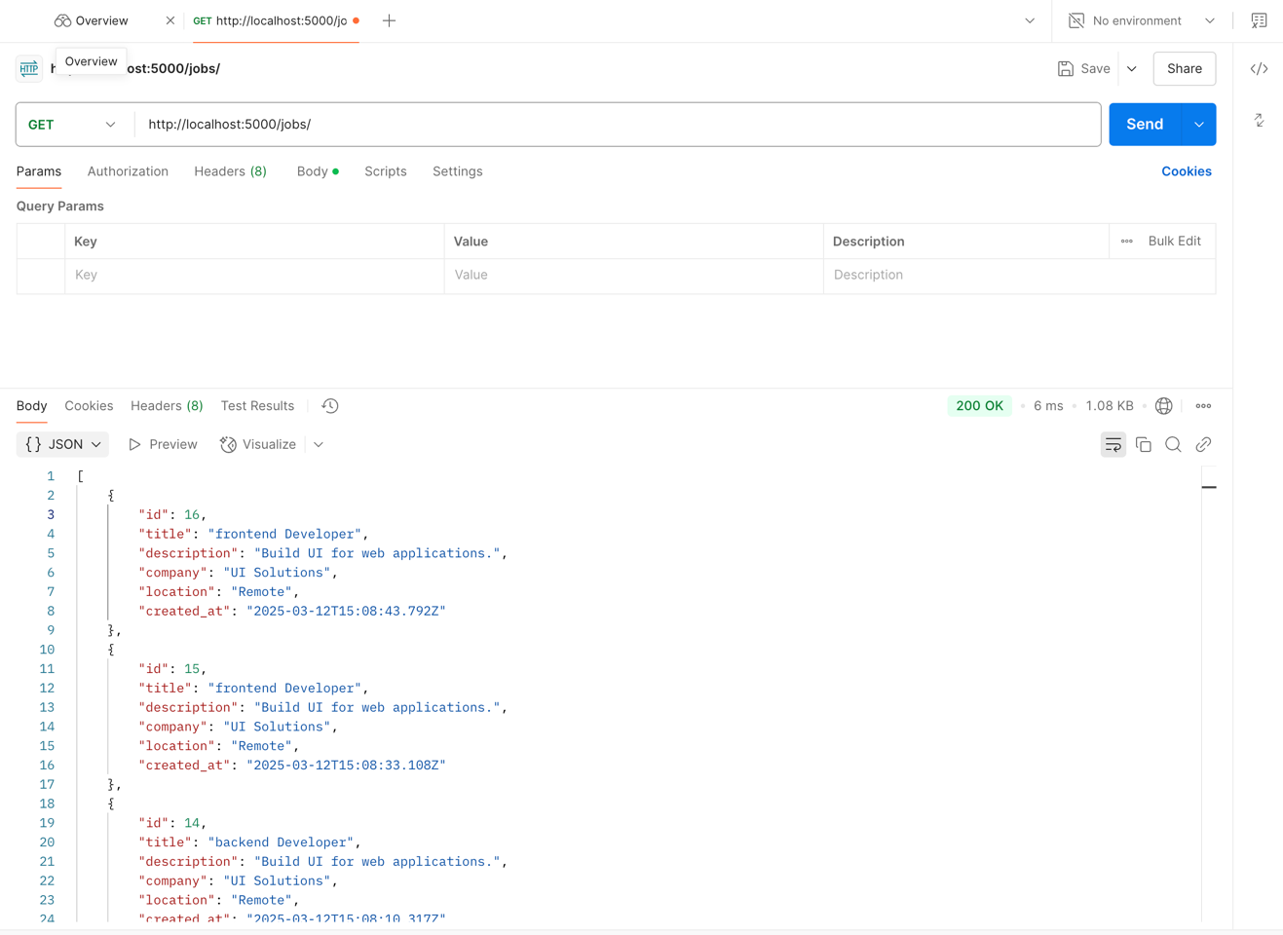

**GET /jobs/:id — returns details of a specific job**

**POST /jobs — creates a new job (input: JSON body)**

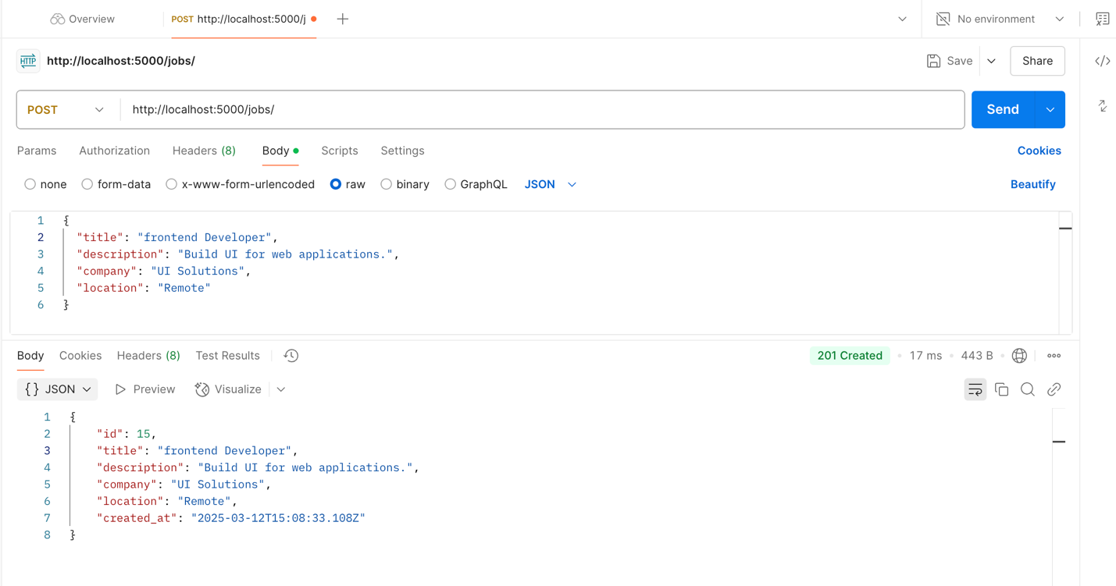

**POST /applications — allows submitting an application for a job (input: JSON**

**body)  
  
**

**GET /applications/:job_id — returns all applications for a specific job**

